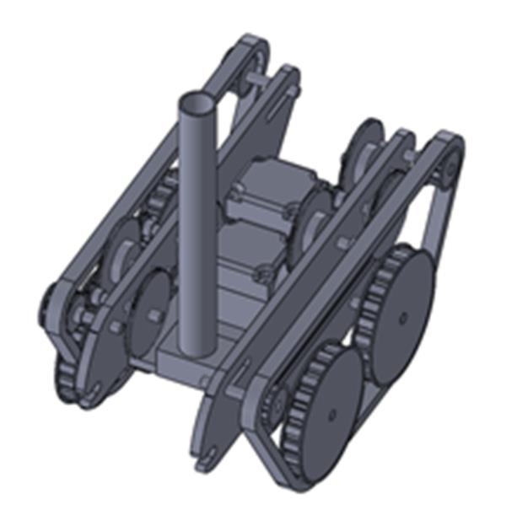

**Backwards Beluga ATV Design Specifications**

**FULL PROJECT VIDEO: [http://youtu.be/VOZmUMjX38w](http://youtu.be/VOZmUMjX38w" \t "_blank)**

**Abstract:**

We designed and constructed an ATV using two AC motors from an electric screwdriver and other provided parts. Our design is based on a two-wheel drive system positioned in the front and back of the ATV, allowing for a zero degree turn radius. The drive wheels were connected to two larger wheels by treads to traverse obstacles that required climbing. Both drive wheels were powered by a gear train involving 24, 44, and 96-teeth gears, designed in a lateral assembly with a 1:128. A high gear ratio was selected in order to maximize the torque of the system, which would later prove to be beneficial for scaling the ramp and other obstacles on the course. The original design for the block and unhitching mechanism involved a “push-cart” design, although this method was eliminated in later design iterations due to logistical problems with climbing the ramp. The final design called for placing the block on top of the ATV, which stabilized the vehicle’s center of mass, and allowed for a successful performance at the competition.

**Design Specifications: Table 1: ATV Specifications**

|  |  |  |
| --- | --- | --- |
| **Specification** | **Value** | **Units** |
| Mass | 1235 | g |
| Width | 19.4 | cm |
| Height | 12.6 | cm |
| Undercarriage Clearance | 4.0 | cm |
| Turning Radius | 0 | cm |
| Drive Train Gear Ratio | 128:1 | n/a |
| Steering Gear Ratio | 1:128 | n/a |
| No Load Horizontal Speed | 0.10 | m/s |
| Safety Factor | 2 | n/a |

**Design Evaluation:**

Throughout this lab our team had many successes even though we encountered many problems. We worked well as a team and did a great job splitting tasks. This helped our team to stay positive throughout the process.We also worked hard to problem solve. Things rarely worked the first time, but we were able to overcome our issues. Our biggest strength was our determination. We did not give up, and we kept trying until something worked, against all odds. The components of our ATV that were successful were the wire support, controller, motor mounts and chassis. Our wire support was effective because it was compact, efficient, light, and well-balanced. Our controller was compact and simple, and it functioned perfectly. Our motor mounts effectively held the motors in place. Also, the gears that we designed and printed to fit over the pinions worked well. The gear train that we designed for both drive wheels ran smoothly thanks to assembly and visualization using Solidworks. We were able to retain most of the output power offered by the motors as a result of strict tolerances and Solidworks models. The pieces of our chassis were well-designed and fit together very well. Laser cutting was a fast and easy way to prototype early on. We put in an enormous amount of effort and did well mostly because of the amount time we spent in Pierce spent designing, building, and troubleshooting.

Although we had many successes throughout this lab, there is definite room for improvement. There are a few design choices that we could have changed that could have improved our performance. To increase our success on the ramp we could have used the third motor for extra torque. We did not account much for power loss due to friction, which made getting up the ramp a slow and difficult process. We could have improved the gear train and prevented power loss by avoiding cantilevers, which caused the axles to be unstable and sometimes allowed the gears to disengage due to radial forces. Additionally, stricter tolerances on the gear train could have prevented the two sides from running at different speeds. If we did choose to keep cantilever gears, we should have at least made the cantilevers shorter to avoid bending. We should also have considered the weight distribution in our ATV. It would often tip back or forward. We could accomplish this by moving the big gears farther apart or the small gears closer together. We could also have decreased the width to improve maneuverability. This could be done by shortening the cantilever beams so that there is room for the motor mounts on a thinner chassis and so that the wheels do not have to stick out so far from the sides. Furthermore, there are a few things that we could have done differently during the assembly process to save time and improve functionality. It would have been helpful to finish our SolidWorks model earlier. We underestimated how valuable SolidWorks could be to determine exact gear placement. We also could have saved time by soldering wires to the motors before mounting them. Finally, we should have added lubrication while we were working in order to better get it into the axle holes.

**Design Process:**

Our design process was divided into five main sections: conceptual development, CAD, assembly, troubleshooting, and practicing. The vast majority of our time was spending in assembly and troubleshooting, which was to be expected since concept development and CAD involve no manipulation of physical elements. The following is a detailed step-by-step list of the procedure we took and some of the problems we came across in designing our ATV. Of particular note is that the design process was (and is) never linear, and upon getting our ATV to work, we encountered a number of different problems that required re-thinking and re-implementation (e.g. finding out that our original design for carrying the cart up the ramp did not work).

1. Conceptual Development

1. Measure size limitations
   1. Account for the bolts in the aerospace tunnel.
   2. Leave clearance for the peg.
   3. Determine the wheel radius requirements for traversing pipes.
2. Calculate the necessary torque and gear ratios.
3. Design the gear train.
4. Create a foam core model to visualize our design.

2. CAD

1. Design the wheels and send them to the 3D printer.
2. Design the motor mounts and send them to the 3D printer.
3. Design the 24-tooth gear to fit over the pinion, and send it to the 3D printer.
4. Design the cart and send it to the 3D printer.
5. Design the sides of ATV with slots for the axles and chassis
6. Design the chassis with enough room for the motor mounts and gear train.
7. Design the tower mount and create G-code.

3. Assembly

1. Laser cut and re-laser cut the sides and chassis to find the correct dimensions.
2. Create gear trains on the sides of the ATV, starting at the drive wheel and moving toward  the motor, repeating the following steps.
   1. Press fit the 24-gear onto shaft.
   2. Drill through the gear hub and axle.
   3. Place the dowel pin in the axle so that the gears and axle will move together.
   4. Correctly space the gears laterally on the body so that they mesh and don’t  interfere with others by using washers and spacers.
   5. Press fit the 96 gear on the other end of the shaft and drill in a dowel pin.
   6. Test stability and rotation.
   7. Repeat until both sides are completed.

c. Screw

1. Test the motor-gear connection and determine motor placement.
2. Laser cut controller pieces.
3. Assemble the controller.
4. Connect the chassis and sides using screws and L-brackets.
5. Laser cut an additional piece to attach to the chassis to hold motors in place (a.k.a. the  “motor-mount mount”).
6. Screw the motor-mount mount to the chassis.
7. Screw through the bottom of the chassis into the motor mounts to ensure they do not  move.
8. Mill the wire tower base.
9. Drill through the bottom of the chassis into the wire tower base.
10. Solder the wire to the motors.
11. Test the motor-gear train connection.
12. Add the large wheels.
    1. The wheels must move freely on their axles.
    2. Use e-clips, spacers and washers to appropriately space the wheels and hold them  laterally.
13. Add tension wheels using threaded rods and hex nuts.
14. Add treads and tension them using the tensioning mechanism.
15. Test the ATV periodically throughout the process.

4. Troubleshooting

1. One gear train did not work because the gears were meshed too tightly and static friction  stopped the gears from rotating. We removed the motor mount and filed 1/16” to the left  so the gears meshed more accurately.
2. The other gear train would periodically stop moving. We added lubrication but this was  not enough. We then moved the drive 1/16” to the right to reduce the friction between the  final two gears. We added a support to support on the the cantilevered gear shafts.
3. Drive wheels rotated at different speeds. The cantilever support helped to reduce power  loss. Then we discovered the motors run backwards at same speed so we reengineered the  car so that the ATV
4. The final problem: How to get block up ramp? First we tried change the latching  mechanism and added a hook to the back of the car. We then tried tying the cart to the hook with a piece of fishing wiring. We test different lengths of the string: short and very close to the ATV, a medium distance, and a string the length of the ramp so the ATV would be horizontal (on top of the track) when pulling the block. When none of these

the motor mounts together, encasing the motor

options worked we tried pushing the cart up the ramp. This also did not work. Finally we tried placing the block on top of the motor mounts. To keep the block in place we added friction tape on top of the motor mounts, and finally we were able to get the block up the ramp.

Finally we held time trials to determine the ATV driver.

**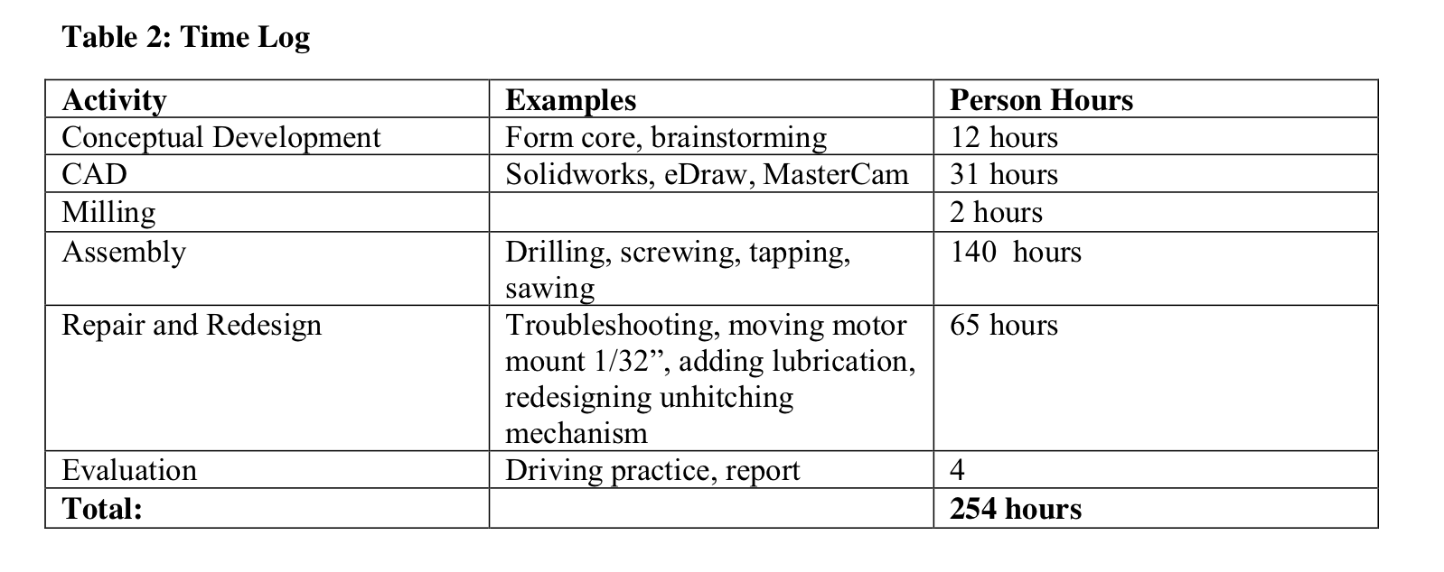**

**Conclusion/Final Comments:**

This was likely one of the most difficult and time-consuming lab any of us have encountered in our time at Harvard, but also one of the most rewarding. The process - from design to machining and assembly - posed several challenges that we struggled to solve but eventually overcame through hard work, perseverance, and lots and lots of help from the teaching staff. What we learned more than anything else during this lab was how to see a project through from conceptualization to implementation and use (in this case a competition). We also learned that multiple iterations and prototyping are key to constructing a successful project. We enjoyed this lab because it is representative of the entire engineering process. We were presented with a task, given constraints, given a team, and were instructed to find a solution. Seeing 250 hours of work pay off when your project accomplishes its task is an incredible feeling. We also learned valuable lessons about teamwork, design, and time management, all of which will be extremely useful to us going forward in engineering or in whatever fields we choose to pursue.

Special thank you to Pete, Andreas, Jordan, and Joe in the lab for all of their help. We honestly would not have been able to finish without them. And a very special thanks to our TF’s Sergio and Nhi, for guiding us through not only our design of the ATV, but also the rest of the class as well. Getting our work done day in and day out would have been infinitely harder without them.

**Appendix:**

 

**Figure 1: Solidworks Assembly of ATV**

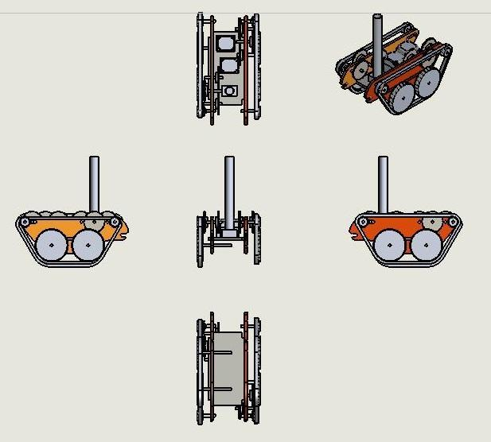

**Figure 2: Solidworks Drawing of ATV**

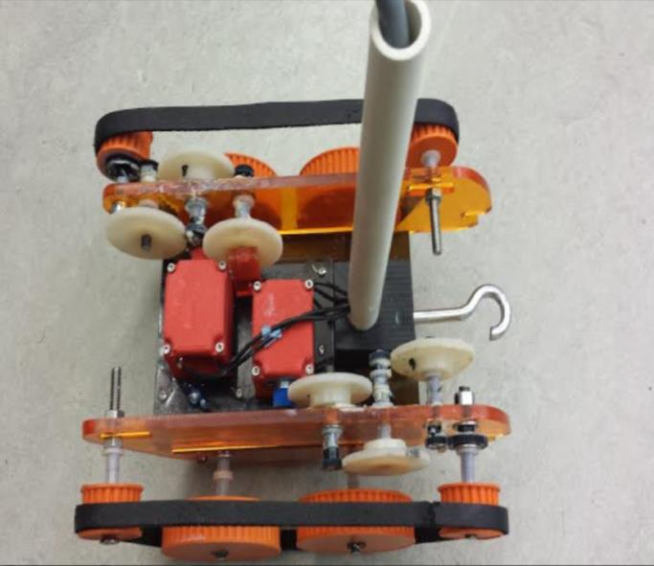

**Figure 3: Photo of ATV**

**Bill of Materials:**

* ●  2 cordless screwdriver motors
* ●  2 DPDT switches
* ●  2 AC Power Connectors
* ●  6 feet of wire
* ●  2 48-tooth Gears
* ●  6 96-tooth Gears
* ●  6 24-tooth Gears
* ●  2 1⁄2” timing belts (for treads)
* ●  2 18” Aluminum rods 1⁄4” in diameter: axels, gear shafts
* ●  ABS: 2 Gears (24 teeth), 4 3” diameter wheels, 4 1.25” diameter wheels, cart, motor mounts
* ●  Acrylic stock 1⁄4” thick: chassis, sides, supports, motor mount mount, cart wheels, controller body
* ●  2x2x2” block of Derlin for wire tower
* ●  6” PVC tubing for wire tower
* ●  Lubricant - Grease
* ●  16 Dowel pins
* ●  4-40 screws
* ●  Washers
* ●  Plastic Spacers